

Biological Safety Cabinet
Class II A2
BSC-4FA2
User Manual

BIOBASE GROUP
Version 2021.06

Preface
Thank you very much for purchasing our class II A2 Biosafety Cabinet.
Please read the “Operating Instructions” and “Warranty” before operating this unit to assure proper operation. After reading these documents, be sure to store them securely together with the “Warranty” at a hand place for future reference.
Warning: Before operating the unit, be sure to read carefully and fully understand important warnings in the operating instructions.

Content

Preface 1
Content 2
1.Unpacking,Installation,Debugging 4
1.1 Unpacking 4
1.2 Accessories checking 6
1.3 Installation conditions and using environment 7
1.4 Installation 7
1.5 Checking after installation 11
1.6 On-site debugging 12
1.7 Test and standard 13
2. User Instructions 14
2.1 Product instruction 14
2.1.1 Product concept 14
2.1.2 Application Range 14
2.1.3 Air filtration system 14
2.1.4 User instructions 14
2.1.5 Circuit of digital control 15
2.1.6 Airflow velocity indication. 15
2.1.7 Differential pressure indication 15
2.1.8 Using of UV lamp 15
2.1.9 Using of socket 16
2.1.10 Installation methods of connect to the external exhaust system 16
2.1.11Technical Parameter 17
2.2 Structural composition 18
2.3 Control panel 18
2.4 The Usage of Remote Control 20
2.5 Methods and procedures for disinfection 22
2.5.1 Operation 22
2.5.2 Structural material maintenance 22
2.5.3 Clean process 22
2.5.4 Vent tank 22
2.5.5 Necessary disinfection 22
2.6 Replacement part list 23
2.7 Wiring diagram 24
3．Common faults & solution 25
3.1 Common faults & solution 25
3.1.1 Warning and reminder 25
3.1.2 Trouble shooting 25
3.1.3 Simple accessories replacement 26
3.2 Label Description 28
4. Warranty 30
Annex 1 31

1.Unpacking,Installation,Debugging
Please firstly check if packing box is in good condition. If the packing box is damaged, please take photos.

1.1 Unpacking
Choose the proper unpacking method according to the actual situation.
Method 1 Necessary tools for unpacking: Electric drill with hexagon dead M8
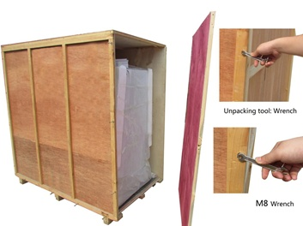
Picture 1
Method 2 Use M8 Wrench to unpack
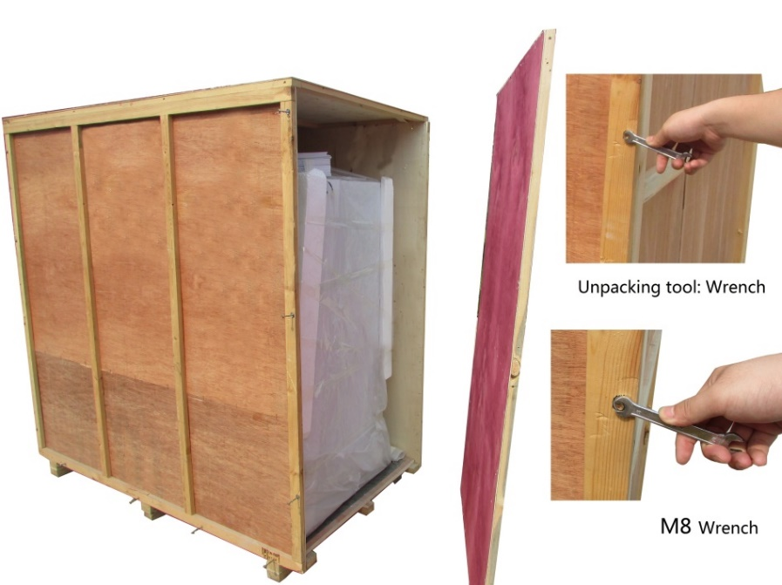
Picture 2
Rapid unpacking diagram(Disassemble the screws shown in below Picture, then move the wooden pieces to right and left)
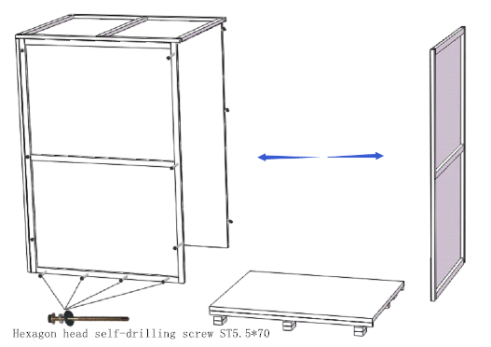
Picture 3
Notes:
- Check the package after receiving the device. Broken glass or other visible damage must be indicated in the equipment receipt, and immediately notify the shipper.
Note: Equipment cannot be returned to the factory, unless receive return authorization!
2) If the device is transported in cold weather, please place it in the area for 24 hours at room temperature before putting it in working place. Please move the equipment as close as possible to where you use it before dismantling packing.
3) Firstly, remove all surface protection. Before the entire device is exposed, do not try to lift off the packing bracket, and make sure you have read the article as below.
4) Unpack the entire package; put away all components for assembly carefully. Left adhesive tape can be wiped with alcohol.
5) Check all parts. If there is damage, please notify the transport company immediately. If the device has problem, do not open the package, because shipper may need to check boxes.
6) Move the equipment off from collet, loosen locking block on the four corners.
7) Safety cabinet is very heavy and is equipped with HEPA filter. They should be transported lightly, It is better to use big trolley to move the safety cabinet and don’t focus the whole weight of safety cabinet at the middle of the work place.
8) Sometimes we need to raise the edge of the cabinet to enter some area, but this is only allowed of a short distance.
9)It is forbidden to make it top-for-bottom or dumping while transporting or placing the Biosafety Cabinet.

1.2 Accessories checking
Refer to the packing list and check the accessories and materials
BSC-4FA2 Packing list
Items | Model | Position | Quantity
Main Body |  | Wooden box | 1unit
Base Stand |  | Placed in two carton box | 1set
UV Lamp (T6 30W) |  | Top or back of main body | 1pc
Protective tube(12.5A) |  | Placed in a transparent plastic bag | 2pcs
Protective tube(6.3A) |  | Placed in a transparent plastic bag | 3pcs
Protective tube(2.5A) |  | Placed in a transparent plastic bag | 2pcs
Protective tube(125Ma,110V)/Protective tube(63mA,220V) |  | Placed in a transparent plastic bag | 1pc
Remote control (including battery) |  | Placed in a transparent plastic bag | 1pc
User manual |  | Placed in a transparent plastic bag | 1pc
Test report |  | Placed in a transparent plastic bag | 1pc
Quality certification card |  | Placed in a transparent plastic bag | 1pc
Drain Valve |  | Placed in a transparent plastic bag | 1set
Stainless steel hex cylinder head bolt M10×20 |  | Placed in a transparent plastic bag | 5pcs
Stainless steel flat washer10 |  | Placed in a transparent plastic bag | 5pcs
Stainless steel spring washer 10 |  | Placed in a transparent plastic bag | 5pcs
Inner hexagon wrench |  | Placed in a transparent plastic bag | 1pc
Big rubber gasket |  | Placed in a transparent plastic bag | 1pc
Small rubber gasket |  | Placed in a transparent plastic bag | 1pc
Front window tubular motor control rod |  | Placed in a transparent plastic bag | 1pc

1.3 Installation conditions and using environment
To avoid disturbances to the safety cabinet and its operator, follow the following guidelines, while determining a suitable location for the cabinet:
- The distance from the plane of the aperture to any circulation space should be at least 1000 mm, so as to preserve a zone undisturbed by anyone other than the operator.
- Biosafety Cabinet should be placed in a position where there should be no opposing wall (or other obstruction likely to affect the airflow) within 2000 mm of the front aperture.
- Safety cabinets should not be installed in positions where they are likely to be affected by other items or equipment. In particular the distance to the aperture of an opposing safety cabinet, fume cupboard, or the edge of a local exhaust ventilation outlet should not be less than 3000 mm.
- Any room air supply diffuser should not be within 1500 mm of the front aperture.
- Doorways should not be within 1500 mm of the aperture or within 1000 mm of the side of the safety cabinet.
- The position of a safety cabinet should satisfy the spatial requirements (e.g. vision, lighting and convenience of access) of the operator and personnel working nearby. When a cabinet is installed on a bench top, the leading edge should be flush with or slightly overhanging the edge of the bench top.
Working environment:
- Only is suitable for indoor;
- Ambient temperature: 15℃～35℃;
- Relative Humidity:≤75%;
- Atmospheric pressure range: 70 kPa～106 kPa;
- Electrical parameters: Consistent with the rated voltage of the Biosafety Cabinet (See 2.1.11 technical parameter performance index);
- Power supply need to be grounded; (Judging method: testing the fire wire and the zero line of the power supply with multimeter, the fire wire to ground voltage should be grid voltage and the zero line to ground voltage should be 0, otherwise the power supply ground is bad).
- Test the voltage stability before using, if the voltage is unstable, should use the voltage regulator, otherwise the control panel and transformer may be easily damaged.

1.4 Installation
- Install the base stand.
- Put upperbody on the base stand and fix it with bolts which are packed in the bag in the work area.Connect the base stand with cabinet.
- Adjust foot caster and work surface, make sure the maximum stability on the uneven ground, clockwise the red part of foot, lower the corresponding supporting feet, lower the height of cabinet, lower four feet at the same time can move the cabinet; rotate the red part of the foot, higher the corresponding base supporting feet, higher the height of cabinet, higher four legs at the same time can make the cabinet at horizontal steady state.
- Remove the internal packaging materials; empty all of the pieces, etc.
Note: any leaving fragments may be damage to fan and HEPA filters.
- Check whether the accessories according to the product packing list.
- Check is there any damage in the process of transportation and check the situation of all components. If necessary, test filter and the fixed bolt on the front panel, these bolts should not be too tight. If you need to check the surface of the air filter, you can loosen bolts fixed well wind network and take it out carefully from the front.
- Check if the work place stable.
- If the safety cabinet is equipped with water tap and gas tap, on the side wall is 1/2 inch threaded pipe joint; Connected to the building or other connection should fit this size.
- Install HEPA exhaust protective device on the exhaust HEPA filters: put the protective device on the opening place of the filter and fix it with nut.
Note: do not put hand into the exhaust air filter at any case.
- Fix drain valve on the bottom floor, connect the drain valve, and check the drain valve in the closed position - in parallel with the ground position, as shown in figure 7.
- The top of the device is equipped with HEPA exhaust protective device, if equipment requires there is an external exhaust system (applied to the poisonous and harmful gas or steam).
Note: there is at least 300 mm clean space between the lab ceiling and the exhaust HEPA filter. If the exhaust HEPA filter is blocked, there will be no enough air flow into the operation area.When the exhaust HEPA filter at the top of the clean room is less than 406 mm, you must test the wind speed at spot.
- Install UV lamp.
- Installation of the main components in Picture 4.5.6.
a. Installation of base stand ，Refer to picture 4 install base.
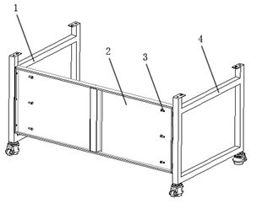
Picture4
1.Right bracket
2.Back connection plate, use six inside hex bolts M10 x 20 to fix with right and left bracket
3. Inside hex bolts M10 x 20, six pcs
4. Left bracket
b. Connect main body and base
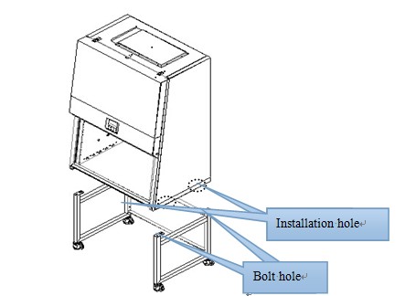
Picture 5
Aligned the mounting holes on the bottom of the cabinet side with the locating bolts, slow down the cabinet on the mounting base.
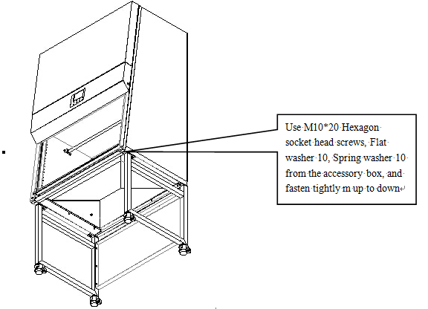
Picture 6
Take out the M10*20 Hexagon socket head screws, Flat washer 10, Spring washer 10 from the accessory box, and fasten tightly according to Picture 6.
c. Installation of Drain valve
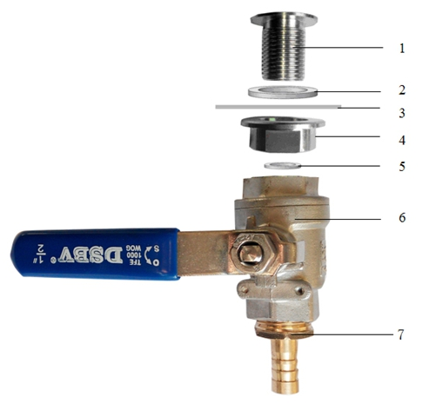
Picture 7
- Drain valve connector
- Shim
- Safety cabinet bottom installation holes
- Ball coupling fastening nut
- Rubber gasket
- Drain valve
- Copper joints
d.Adjustment of Footmaster Caster
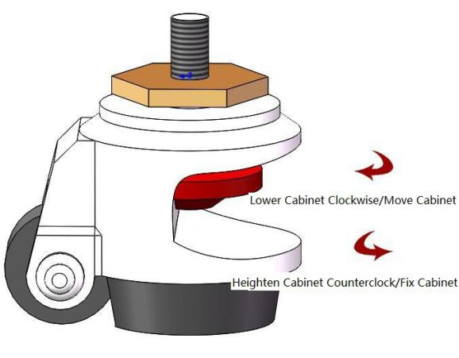
Picture 8
Clockwise rotate caster’s red part to low down the base feet and the height of the cabinet. Low down all four casters can move the cabinet position. Counterclockwise rotate caster’s red part can rise the base leg and height of cabinet. Raise all four casters at same time can fix the cabinet. Adjust the four Foot -masters makes the cabinet stable.
e. Installation of water tap, gas tap
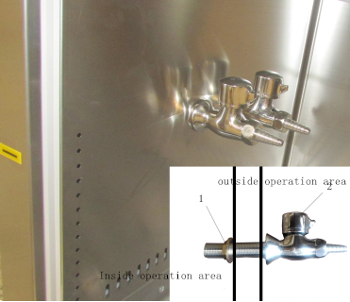
Picture 9
1. Tighten nut 2.The tap/gas tap
Pick up the water tap, gas tap and tightening nut, install as shown in Picture 9.

1.5 Checking after installation
Checking Items | Normal situation
Wind speed display | Inflow(100-110)FPM, downflow(60-70)FPM
Pressure display | exhaust filter80-120Pa, downflow filter 80-120Pa
Fan operation | The fan running
Fluorescent lamp | Lamp lights after pressing button
UV Lamp | Lamp lights after pressing button
Display screen buttons | All buttons can be used
Socket | Press the socket key, multimeter testing output supply voltage
1) Connect the Biosafety Cabinet dedicated power line to power outlet on the ground, electric current is 9A, Biosafety Cabinet must be the only equipment on the circuit to ensure that does not exist in any other equipment, see the electrical equipment requirements data in the cover.
2) Open the Fan key on Control Panel; fans will take some delay in order to achieve the required speed. And in order to prevent too much current, the fans need a delay of about 10-15S in order to achieve full speed before motor running. Similarly, the fans also need 10-15S delay to stop. Stable voltage is provided by built-in voltage regulator circuit for the motor / blower, thus eliminate air fluctuations.
Note: Please stop the fan before shut off power.
3) Press the LIGHT button on control panel, turn on the lights. If the lamp is not bright, please check lamp-tube or socket, it may course loose between the lamp and lamp holder in the carrying process.
4) Press UV button on the control panel; turn on the UV lamp and to check whether UV light is working properly.
Note: Only when the glass door is closed, UV can work.
5) Press key SOCKET button on the Control Panel; check the safety cabinet’s internal power socket. If the safety cabinet equipped with two sockets, button controls both of them.
6) Press the mute button on the control panel to start the sound attenuation function, press again to restore alarm.
7) Continue to press door up buttons on the control panel, glass door will continue rising, automatic stop when up to10 inch, press this button again and the glass door will continues rising.
8) Continue to press door down buttons on the control panel, glass door will continue dropping, automatic stop when down to10inch, press this button again and the glass door will continue dropping.

1.6 On-site debugging
Before packing and transport, Biosafety Cabinet has been tested and confirmed at our factories, but another test must be adopted. Only qualified personnel can adjust device, in order to ensure the accuracy of the on-site testing, test equipment must be calibrated. If you can not implement this operation, please contact the manufacturer for you to provide local on-site testing services company names.
On-site debugging should include at least the following:
-Application of aerosol detection technology, check exhaust HEPA filters need a aerosol generator and calibration photometer;
- Check the safety cabinet’s inflow while working;
- Check the safety cabinet internal decline airflow rate;
- Check airflow inside the cabinet by using smoke simulator;
- When the cabinet connected to building exhaust system, balance the air emission.
The safety committee to ensure that your new equipment accurate on-site inspection, the equipment cannot be used without the pretest taken by safety committee.
Do not adjust the fan speed in the absence of fully testing of decline wind speed and the inflow air. If the manufacturer has already set the correct air flow, generally do not require further adjustments. Do not change the valve set of the ratio between the exhaust and air supply, unless qualified personnel think it necessary to do it.

1.7 Test and standard
1) Filter leakage test
The standard aerosol testing tests the integrity of the HEPA filters, generally tested annually. Qualified personnel must use calibrated device when aerosol testing. Ref to the list provided by factory. Some associates have specific requirements about the aerosol test.
2) Air adjustment of the opening of the work area
The exhaust HEPA filter should be installed on the top of the Biosafety Cabinet. The air volume exhausted is equal to the air volume entering from the working opening. The average velocity entering the opening of the work area has been identified when designs the Biosafety Cabinet. The test should be conformed the rules of the NSF49. The opening air velocity testing data see the APPENDIX 1.
To adjust the fan speed adjustment should be according to the data specified in the APPENDIX 1.
To set the air velocity of the opening work area correctly.
We emphasis again that only the qualified people can use the calibrated equipment to carry out the adjustments. If there is some difficulties PLS contact the manufacturer.
Note: the adjustments must be made in conjunction with the down flow air velocity profiling section 3. And it is necessary to have a balance test between them.
3) Downflow air velocity:
The equipment should be balanced by it. And generally only the adjustment outlined in section 1.7 required. However when the HEPA filter blocked for more accumulations the readings on the static pressure monitor increased (located on the control panel). The fan speed needs to adjust so that can rebuild the correct air velocity within the working chamber. The equipment designed the air split. And we can control the exhaust and inflow air ratio by adjusting the positions of the grids in the air split. The setting is done in the factory and generally need no adjustment. The equipment correct settings and the testing data see the APPENDIX 1.
NOTE: The adjustment of the balance of the air velocity must be carried out by the professional person.

2. User Instructions

2.1 Product instruction

2.1.1 Product concept
Biosafety Cabinet meet the standards of NSF/ANSI49-2012. However, the A/B3 is the old version.
The equipment has the following three functions:
- Protect the operators against the hazardous particles or hazardous particles in the air.
- Provide the clean working area, prevent the air pollutants from touching the working bench.
- Prevent the cross-infection of the samples on the sides.

2.1.2 Application Range
Biosafety Cabinet is necessary equipment in the laboratory in the search of microbiology, biomedical, DNA recombinant, animal experiment, and biological products, especially in the occasion that operator need to adopt protective measure, such as medical and health, pharmacy, medical research. Our equipment provides a safety working environment which don’t have bacterial and dust in the process of bacterial culture.

2.1.3 Air filtration system
Picture 10 is the air flow pattern and protected area. The air filtration system is the most important system, which consists of blower, air duct, supply filter and exhaust filter.
The function of air filtration system is transferring filtered air to work area, ensure the average down flow velocity is (62-68)FPM, meanwhile, it can purify the exhaust to prevent environmental pollution.
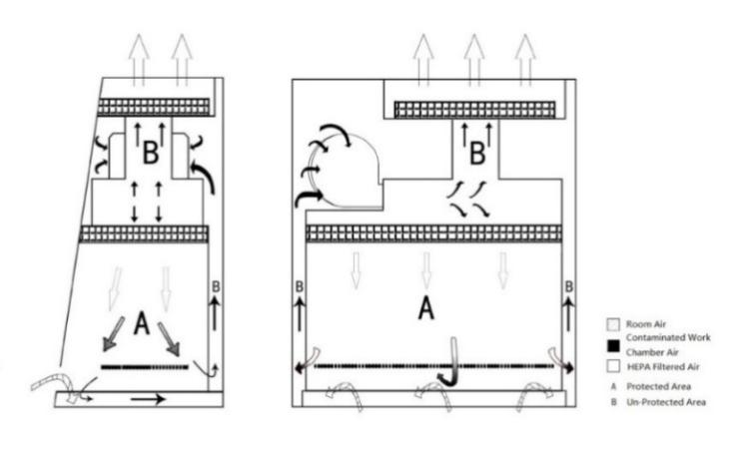
Picture 10

2.1.4 User instructions
- This equipment can work continuously, but in order to extend HEPA’s life time, we can open only when need. Power on the equipment for several minutes before using, to ensure the steady flow in the cabinet. If the cabinet is placed in the polluted area and no running, we should close the front window. However, don’t operate the cabinet when the front window is closed.
(b) Using the disinfector wipe the inner of the work area, before running the equipment.
(c) When open the fan, read the pressure degree.
(d) Check drain valve and make sure it’s off.
(e) Arrange your experiment process carefully, don’t mess the work area.
(f) When the cabinet is running, it can storage clean instruments, but not too much.
(g) When sampling operation is finished, the samples should be moved to the left or right of the sampling dish. Correct operation can make sure there is no cross infection of the samples in the cabinet.
(h) Note: The operator’s arm and hand maybe the pollution source, so the operator must wear sterilized gloves or wash hands using sterilization soap. The used gloves should be gotten off from the sleeve of lab-gown.
(i) When the room air or adjacent working area air is serious polluted, we should take measures to prevent the particle from entering into the clean working area.
(j) The most basic is placing the instruments to the right place. If don’t know the place, using airflow meter to check, to make sure the right airflow pattern.
(k) Don’t block the air grill, especially after we used the sterile rag.

2.1.5 Circuit of digital control
(a) Our Biosafety Cabinet use the latest microprocessor control technology to monitor your safety cabinet’s function, easy to operate, with friendly interface and automatic diagnostic function.
(b) Connect safety cabinet to the recommended power interface.
(c) After power on, the LCD display will display the cabinet’s working time, and filter’s working time and the life time. When push the power button, the LCD display background lights up, the system will be in standby mode.
(d) After power on, the equipment will check itself automatically. When the front window is too high, it will alarm buzzer, and the LCD display will show “!” and flicker, now you can adjust the height of the front window. If the differential pressure of the supply filter and exhaust filter are too big, there will be audio and visual alarm, then we need to replace the filter, to ensure the safety of operator.
(e) After self-examination, the equipment will be in standby state.
(f) The fan run by activating the switch on the control panel, the Fan sign on the LCD display will light, meanwhile, the motor will start, and it will reach the normal speed after 10-15 seconds.
(g) When activate the fan switch again, the motor and the sign of fan will close, and the motor will shut down after 10-15 seconds.
(h) Three-pin socket is controlled by the relevant key on the control panel, the max current is 5A. If there are two three-pin sockets, they will be controlled at the same time.
(i) The digital controller can adjust all velocity of the fan, and it can provide the linear compensation for voltage fluctuation.
(j) The airflow volume will be displayed and monitored through the pressure, and will be sampled by the microprocessor. When the airflow volume exceed the normal value, the buzzer will alarm continuously.
(k) Before seeking the maintenance service help, pull the plug off the wall, then plug in to restart the motor after about 2 minutes, the safety cabinet will restart and run well. But if the cabinet can’t start, then seek the service.

2.1.6 Airflow velocity indication.
Airflow velocity indication is inflow velocity and down flow velocity.

2.1.7 Differential pressure indication
Differential pressure indication is the differential pressure between upper and lower filter, and it will increase when the filter loading increase. The value after the Exhaust filter is the exhaust filter differential pressure, the value after the downflow filter is the supply filter differential pressure.

2.1.8 Using of UV lamp
Using UV lamp to sterilize the equipment for at least half an hour before and after use. When sterilizing, the operator had better leave the room to protect eyes and skin.

2.1.9 Using of socket
The switch of socket is on the control panel, on the circuit board there is a 6.3A fuse for overload protection. The power supply provided by the socket is 110V, 60Hz or 220V, 50Hz/60Hz, and the maximum current is 5A.

2.1.10 Installation methods of connect to the external exhaust system
About the installation of Biosafety Cabinet exhaust HEPA filter connected to an external exhaust system, we supply the following Suggestions.
When the Biosafety Cabinet is connected to the efflux system, it must be 100% efflux system.
1)Top pipe connection
(a) Typical installation is shown in figure 11.
Whether the safety cabinet is working, the exhaust hood can always provide continuous stable gas flow exhausting outdoor. The total exhaust air rate of the exhaust hood is no less than 100m3/h of safety cabinet’s gas displacement, gas displacement of safety cabinet BSC-4FA2 are separately 460m3/h.
(b)When the safety cabinet vent to a public exhaust system, this connection method is also available.
(c)To make sure the disordered airflow inner side dose not leak to air outside; air curtain should be used to check the unclosed roof.
(d) Ensure that there is no air exhaust fan working in the distance when the cabinet working. Air exhaust fans on the building should be locked to cabinet’s supplier, or there should install a switch or similar device on the laboratory’s exhaust system.
(e)To set the suction on the top correctly, there need an air throttle on the gas exhaust pipeline.
(f)Adjust the air flow balance by qualified person.
We can provide exhaust controller for connection the outside pipe. Each exhausting control combination need an alarm monitoring system, including low flow alarm and high flow alarm.
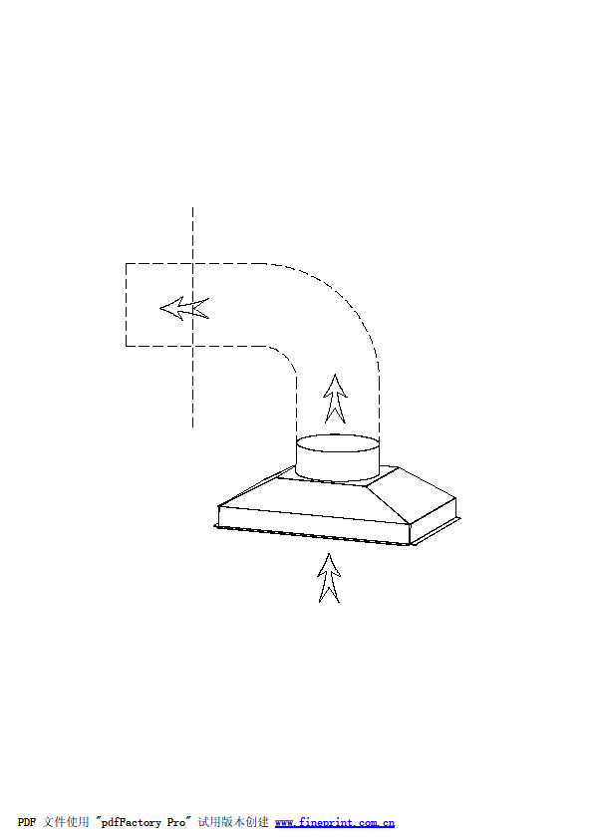

Picture 11

2) Hard connection belongs to A2 safety cabinet’s special operation method. If you need to use this method, please contact us.
3)Flow alarm system instruction
Flow alarm system is an independent software package programmed in advance to monitor the abnormal of air volume. It alarms when the air volume exceed normal value.

2.1.11Technical Parameter
Model  Technical parameter | BSC-4FA2
Rated voltage AC | AC230V 50/60Hz; AC115V,60Hz
Rated frequency | 50 Hz □ 60Hz □
External Size(W*D*H) | 1383×775×2295mm
Working Zone Size(W*D*H) | 1210×600×660mm
Rated current | 9A
Airflow Volume | Inflow: 462m³/h(272cfm)  Downflow: 65%:863m³/h(507cfm)  Exhaust: 35%: 462m³/h(272cfm)
UV Lamp Consumption | 30W
Illuminating lamp | 18W*2
HEPA Filter | 99.995％(Diameter:0.3μm)
Noise | NSF 49≤67dB(A)
Notes: (1) Electric consumption power including power which operation area needs to load(Loading no more than 500W)
(2) Our company reserves the right of product design changes, if there are any design change, without prior notice.

2.2 Structural composition
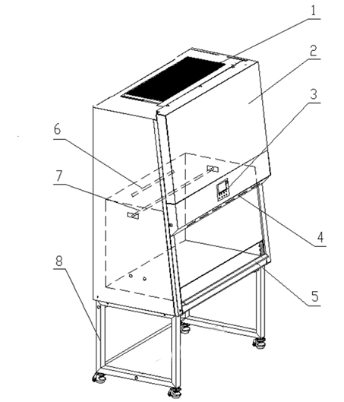
Picture 12

- Air Outlet safety guard 5.Alarm rest plate
- Control panel 6.UV lamp
- LCD display 7. IV bar
- Fluorescent lamp 8. Base stand

2.3 Control panel
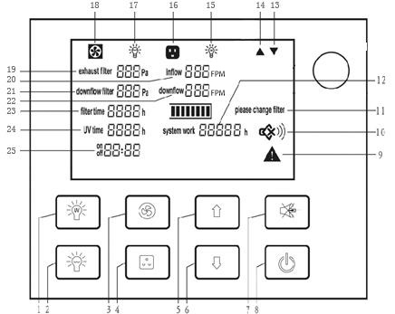
Picture 13

1.UV lamp | 14.Glass window up status
2.Fluorescent lamp | 15. UV status
3.Blower | 16.Socket status
4.Socket | 17. Fluorescent lamp status
5.Glass window up | 18. Blower status
6.Glass window down | 19. Exhaust filter differential pressure
7.Mute | 20. Inflow velocity
8.Power | 21. Supply filter differential pressure
9.Alarm status | 22. Downflow velocity
10.Mute status | 23. Filter working time
11.Filter changing status | 24. UV lamp working time
12.System working time | 25. Reservation timing
13.Glass window down status

  - LCD Screen
The working status of the equipment and operation can be seen on the LCD screen.
  - Soft touch button
BSC’s main functions could be executed by touch-buttons. User can operate the BSC either by pressing the buttons on control panel or using the remote control. There are totally 8 common button on control panel.
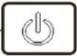: The power button: Master switch to control other function keys
: To control fluorescent lamp. When you press each time, the status of the fluorescent lamp and the corresponding status counter on the LCD change at a time from bright into extinguish or the opposite.
: To control UV lamp. When you press each time, the status of the UV lamp and the corresponding status counter on the LCD change at a time from bright into extinguish or the opposite. (It works only after front window, fluorescent lamp, blowerfully closed.)
: To control blower working status. When you press each time, the status of the blower and the corresponding status counter on the LCD change at a time from bright into extinguish or the opposite.(It will not work when front window is fully closed.)
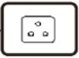: To control socket power status.
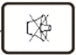: Press MUTE button to stop voice prompt
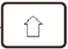: Press UP button, glass window will raise. Stopping at10inch distance units panel. Continue to press UP button until it reached its lowest point, glass window will stop move when loose the button.
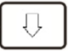: Press Down button, glass window will fall down. Stopping at10inch distance units panel. Continue to press Down button until it reached its lowest point, glass window will stop move when loose the button.
There are totally 8 common buttons on control panel.

2.4 The Usage of Remote Control
In order to solve the problem that is inconvenient for the user to operate in close range operation, the Biosafety Cabinet is equipped with a special remote control The control panel has the advantages of small volume and light weight, and can control the whole function of the Biosafety Cabinet in the range of 6 meters and 30 degrees before the cabinet. Therefore, it can be carried to operate by the user. The controller adopts imported special chip, which has the characteristics of good anti-interference performance, long distance remote control and high control precision.
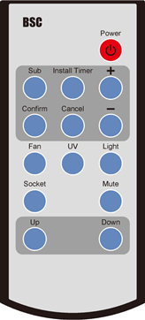  Picture 14 | Functions of Control panel:  1.Power  2.Sub  3.Install Timer  4.Confirm  5.Cancel  6.Turn Up(+)  7.Turn Down(-)  8.Blower status(FAN)  9.UV lamp(UV)  10.Fluorescent lamp (LIGHT)  11.Socket status(SOCKET)  12.Mute status (MUTE)  13.Glass window up status(UP)  14.Glass window up status(DOWN)
Remote Control
- Reservation Time (SUB)
- Connect power, open power lock, and press the reservation timing button (SUB);
- Adjust the time (minutes) by “+” or “-” button. Press the confirmation button (CONFIRM) to confirm; and then adjust other minutes and hours position data in the same way;
- After the time is confirmed, the corresponding display lamp lights by selecting the function buttons (such as UV);
- Press the POWER button again, the reservation function starts. Reserved time starts count down. The corresponding setting function starts when the time counts down to zero.
- Timer (INSTALL TIMER)
- Connect power, open power lock, press button (POWER), the corresponding display lamp lights by selecting the function buttons (such as UV);
- Press button (INSTALL TIMER), adjust the time (minutes) by “+” or “-” button. Press button (CONFIRM) to confirm; and then adjust other minutes and hours position data in the same way;
- After the time is confirmed, the Timer function starts. When the time counts down to zero, all the functions will be off, the cabinet will be in standby mode.
- Application of Reservation Time
Biosafety Cabinet is equipped with special UV lamp. When turning on or turning off the cabinet, sterilization time of UV lamp should be at least 30 minutes. In order to save the waiting time of turning on or turning off the cabinet, we develop reservation time function. It realizes function of automatic turning on or turning off the cabinet after the sterilization finished. Reservation time setting range is from 0 to 99 hours and 59 minutes. This function helps operators to save time and improve efficiency.

2.5 Methods and procedures for disinfection
Besides general cleaning, the equipment system need little maintenance. The accurate regular field evaluation time interval is determined by Security Office and Safety committee. Maintenance measures below do advantage to the equipment’s longer service life and keep best work performance.

2.5.1 Operation
Biosafety Cabinet can work 24 hours around, all circuit and motors are fully protected. Leakage protector is necessary, we suggest to switch in leakage current protector on the socket or circuit control board of the machine, which is easy to realize.

2.5.2 Structural material maintenance
Form 1 list out the clean method for different materials
Note: Special coat in the surface of equipment may be damaged if often use power with abrasive compound to do cleanness.
Material | Recommended clean method
Stainless steel | Wipe the entire surface with a soft cotton cloth or towel soaked with concentrated liquid soap(like SWIPE, Mr. Clean, etc.), then wipe up the soap with another cotton cloth or towel soaked with clean hot or warm water, and then wipe the surface with a dry cotton cloth or towel rapidly. Clean the extra soap lather with dry cloth or towel.  For the contaminated or dirty work surface or sump, use mild abrasive compound like SPIC or SPAN then wipe following above.
Surface coating | Use soft cotton cloth or towel(not lint) to wipe the surface with non-abrasive household cleanser like FANTASTIC or BON AMI, but not abrasive compound like AJAX or COMET
Form 1: Recommended clean method

2.5.3 Clean process
Raise the front glass window to make it easier to clean the whole inner workplace. The clean process is decided by agent and follow suggestions from safety office and safety committee.

2.5.4 Vent tank
The sudden leaking of any liquid in workplace may be stayed on the workplace or flow into Vent tank which is around the workplace. Stainless Vent tank can use draining valve to dredge.Under normal condition, the draining valve should keep closed.
Note: The Spillage could take NSF-49 as a reference.
Before disinfection, please don’t move the front grating or draining valve.

2.5.5 Necessary disinfection
-Before working
-Before changing the filter
-Before performance checking(unless it is a new machine and never used)
-Before moving the equipment
-Start an entirely different working program
-When the safety office or safety committee requires
Note: Only the safety office or safety committee can determine the right disinfection method.

2.6 Replacement part list
BSC-4FA2 Replacement parts list
No. | Designation | Specification
@aat01 | Lamp holder T8 | FL011-W
@aat02 | UV Lamp | T6 30W
@aat03 | Fluorescent Lamp | LED 18W
@aat04 | UV lamp ballast | T6 30W TBE-232FWc
@aat05 | Upper filter (Exhaust filter) | 800*430*69
@aat06 | Down flow filter (Supply filter) | 1240*500*69
@aat07 | Fan | Wheel DD10-6A 1/2P  Motor 5SBA39GL
@aat08 | Control panel | LCD control board (strong circuit board, weak circuit board, display screen)
@aat9 | Remote control(with batteries)
@aat10 | Glass | 1314*700*6.76mm

2.7 Wiring diagram
Picture 15

3．Common faults & solution

3.1 Common faults & solution

3.1.1 Warning and reminder
Digital display of pressure difference, digital velocity display, audible and visual alarm system.
1) Over safety height alarm for front window.
There will be audio and visual alarm when front window is lifting over safety height. Same time LCD display will twinkle exclamation mark. Then just adjust the height of the front window.(Front window height setting value is 10inch)
2) HEPA filter pressure difference alarm.
There will be audio and visual alarm if pressure of air supply filter or exhaust filter can’t meet present value, at the same time LCD display will twinkle exclamation mark. Remind the operator to replace the filter immediately to protect the operator’s safety.
3) Velocity fluctuation alarm.
There will be audio and visual alarm if the inflow velocity and down flow velocity below 20% of the standard value, namely, inflow velocity below 83FPM, down flow velocity below 51FPM, at the same time LCD display will twinkle exclamation mark to remind the operator pay attention.

3.1.2 Trouble shooting
Please confirm whether the power is connected or not, whether the power cord is obvious damaged, whether the fuse is good before the fault diagnosis.

Faults | Measures
Equipment doesn’t work | (a)Check whether the power socket inserted tightly  (b)Check whether these three insurance tube of circuit board burned out :zero line insurance tube F3 12.5A, fire line insurance tube F2 12.5A, transformer insurance tube F1 125 mA.  (c)Transformer fault or cable poor contact can lead to circuit board working voltage abnormal.
Blower doesn’t work | (a)Check whether the motor is broken  (b)If components or the circuit of control panel is broken  (c)Check whether the circuit is well connection  (d)Check whether the blower circuit board fuse F4 6.3 A is burn out .
Motor with buzzing | (a)Replace motor  (b)Low fan speed settings
fluorescent /UV lamp doesn’t work | (a)The corresponding lamp broken  (b)Components or the circuit of control panel is broken  (c)The corresponding ballast broken  (d)Check whether the circuit board fuse is burn out. Fluorescent F6 2.5A, UV F5 2.5A
Motor or fan set has a scratch or friction | (a)Check the fan cage for debris, pieces of paper, packaging, etc.,and remove them  (b)The wind impeller may slide on the motor shaft, replace the fan
Air speed too low | (a)The speed of the fan is set incorrectly  (b)Check whether the HEPA filter is blockage, check pressure readings  (c)Air flow need balance between input and output.
Front window doesn’t work | (a)Check whether the circuit board fuse F8 6.3A is burn out  (b)Motor damaged, replace the motor
No electricity in socket | (a)Didn’t turn on the socket  (b)Components or the circuit of control panel is broken  (c)Check whether the circuit board fuse F7 6.3A is burn out.
 (1)The above electrical parts must be operated by a qualified electrician in safety conditions (cutting off power supply). The other parts are not allowed to remove; otherwise the user should take responsibility by them;
(2)When failures are not occur, and the operator can’t solve, please notify our maintenance department immediately. For your safety, please do not maintain equipment by yourself;
(3)The maintenance of this equipment is undertaken by trained and recognized technicians;
(4)If you need to order parts, contact the agent or our technical service department, and please indicate the model and serial number of the cabinet purchased.

3.1.3 Simple accessories replacement
1) Replace fluorescent light
When replacing lights, make sure that the power is off, open the operation panel like shown in Picture 16, use the control panel support frame (fixed in the inside position of the control panel as shown), then as Picture 17 shown rotary screw off the tubes, take the correspondence type of lamp, put it to the lamp holder and rotary screw to the right position in the opposite direction.
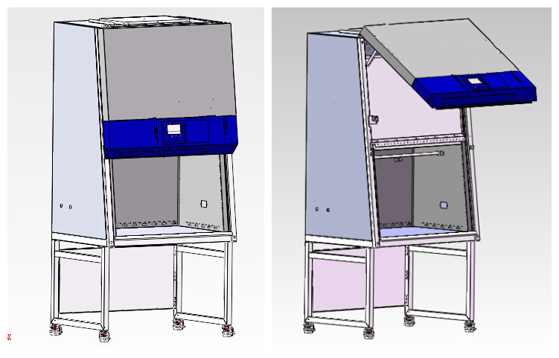
Remove the two hole plugs from the left and right sides. Use screwdriver to loose the screws

Fluorescent lamp
Take out one tip of support bar behind the control panel to mount on the cabinet

Picture 16
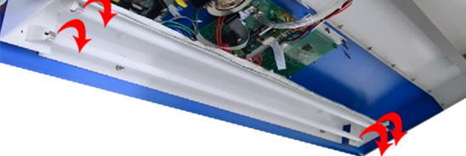

Picture 17
2)Replace the UV lamp
UV lamp should be replaced regularly according to the frequency of use, when using UV lamps reach to the time of 600 hours, we recommend to replace the lamp. When replacing, first make sure the power is off, Rotary screw off the tubes, take corresponding models of the UV lamp tubes, and then rotary screw the bulb and take it off, then take the correspondence type of lamp, and put it to the lamp holder and and rotary screw in reverse direction.After replacing the UV lamp, it needs to keep pressing the button of UV for about five seconds when the machine stays standby, when hear a alarm voice, UV lamp use time is zero.
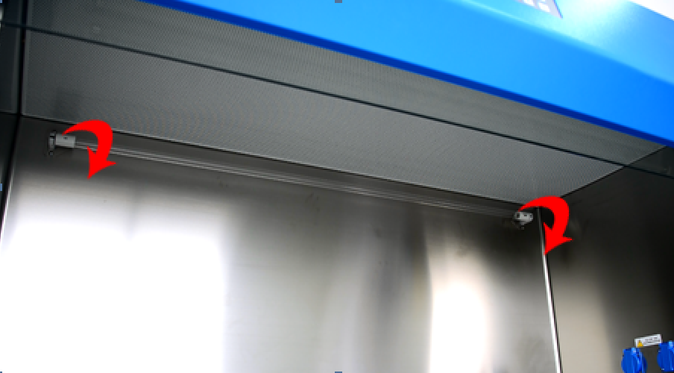
UV lamp
Picture 18

3.2 Label Description
- Biological hazard label

Picture 19
- Ground symbol


Picture20
- Glass door super elevation warning label


Picture 21
- MET

Picture 22
- Warning note
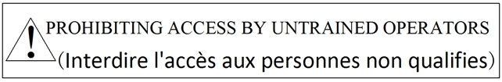
Picture 23
- DECONTAMINATE note
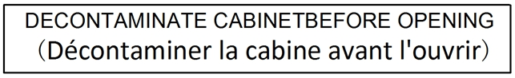
Picture 24

4. Warranty
We provide warranty for all Biosafety Cabinet that purchase from our company,and will abide by the following terms and conditions:
(a) 18 months warranty period is as follows;
Warranty is 12 months after delivery,include the machine and parts;
The following 6 months only guarantee parts;
The ports excluding consumable accessories, such as lamp, filter;
(b) For defective parts or materials, we have an obligation to replace or repair.If not received the return authorization, you cannot return the equipment to factory;
(c)We will take no responsibility for risks caused by improper operation and man-made damages during the warranty period.
(d) This warranty Bill does not pay the trip fee of repairing, replacement and returning to the buyer.
(e) My company should service or repair products in the area of the buyer, buyer should ensure that the product has been disinfected in advance.
(f) Without our company written agreement, do not do any modification and change for equipment and other parts, otherwise, at one’s own risk.
(g) We provide lifelong maintenance service for Biosafety Cabinet, If need provide door-to-door service, we will charge door to door service fee over guarantee period.
In addition to the above warranty Bill involves the clause, the other will not be guaranteed.

Annex 1
Biosafety Cabinet
The setting of the downflow and inflow velocity
Measured by Air Flow Anemometer
Model | type | Inflow Velocity | Downflow Velocity | The reading of the Highest point and lowest point
BSC-4FA2 | A2 | (100-110)FPM | (60-70)FPM | Average  ±15.7FPM

BIOBASE GROUP
2# building, No.9 Gangxing Road, High-tech Zone, Jinan City, Shandong Province, China
Tel: +86-531-81219803/01
Fax: +86-531-81219804
Inquiry: export@biobase.com
Complaints: customer_support@biobase.cc
After-sales service: service_sd@biobase.cc; service_ivd@biobase.cc
Web: www.biobase.cc/www.meihuatrade.com / www.biobase.com

